Mold Design and Manufacturing

# Mold Cavity Design:–

This project involved design of Mold and its manufacturing for a variety of parts used in the irrigation system as pipe fittings. Most of the parts had a deep undercut on the inner surface due to which, a normal single inner core was avoided and a sliding/collapsible core was used instead. Some of the molds were manufactured using lathe and milling CNC machine which were inputted with CNC program generated on the computer on DELCAM software. Some of the parts and their molds have been shown below.

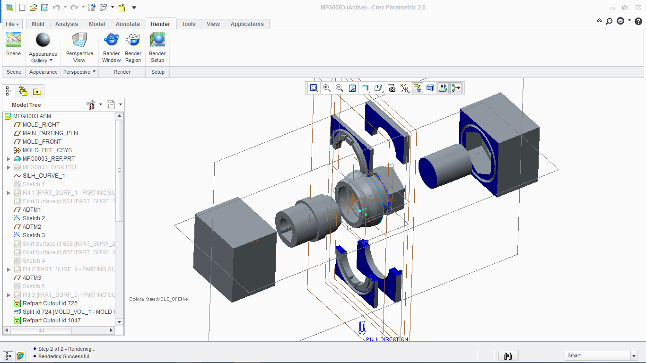

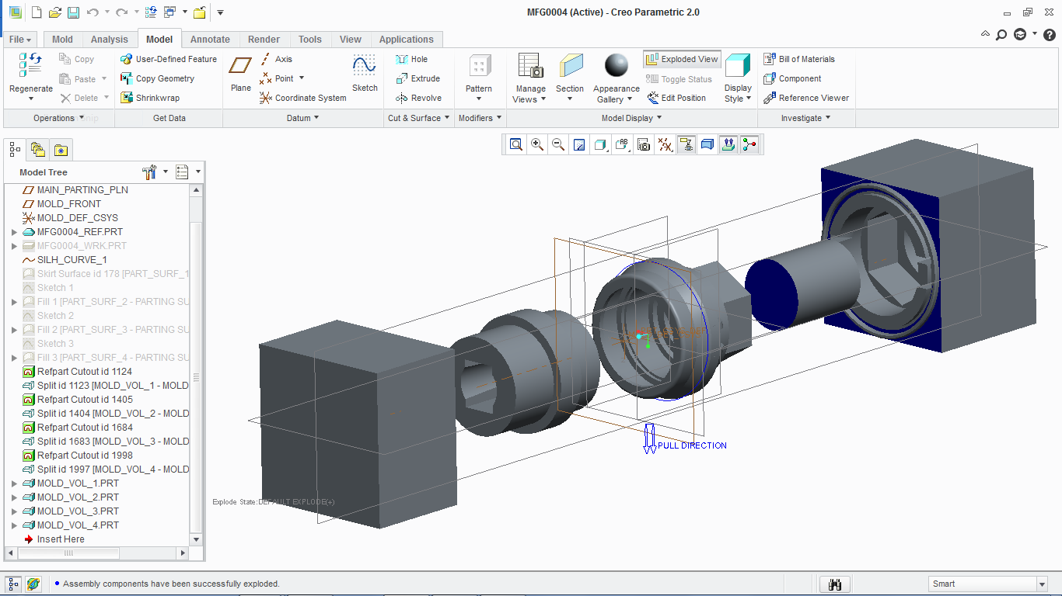

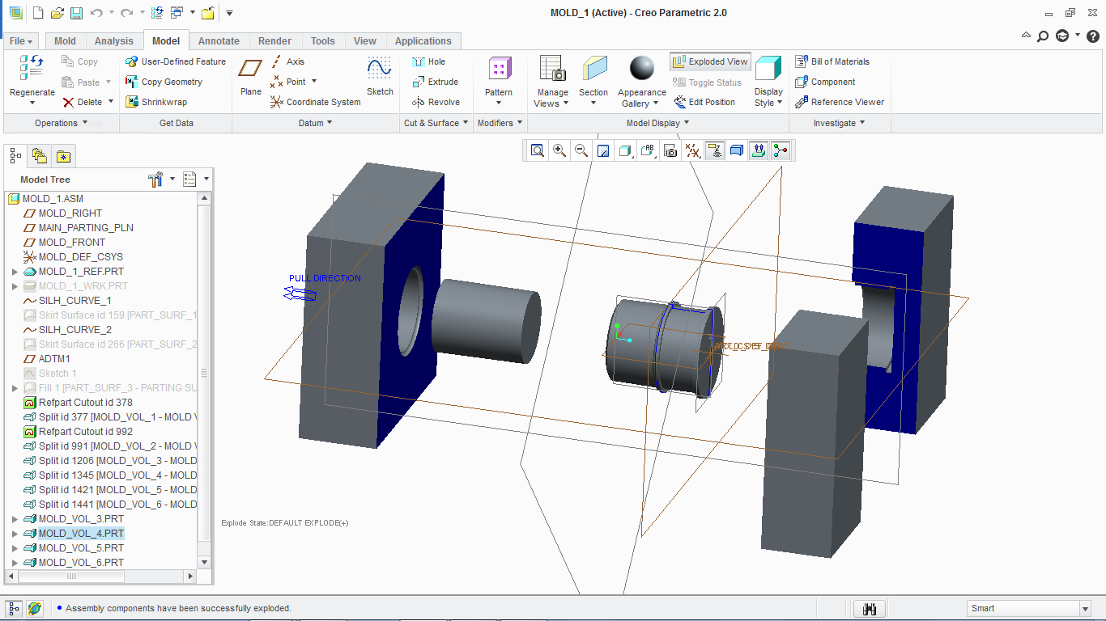

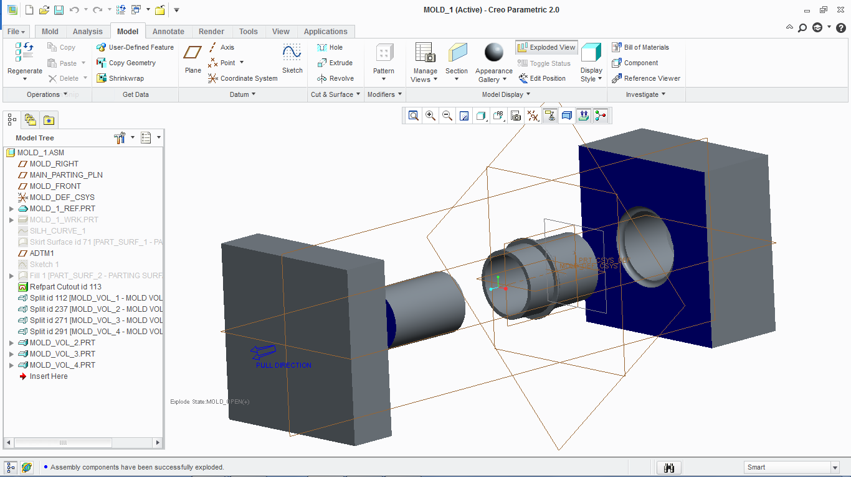

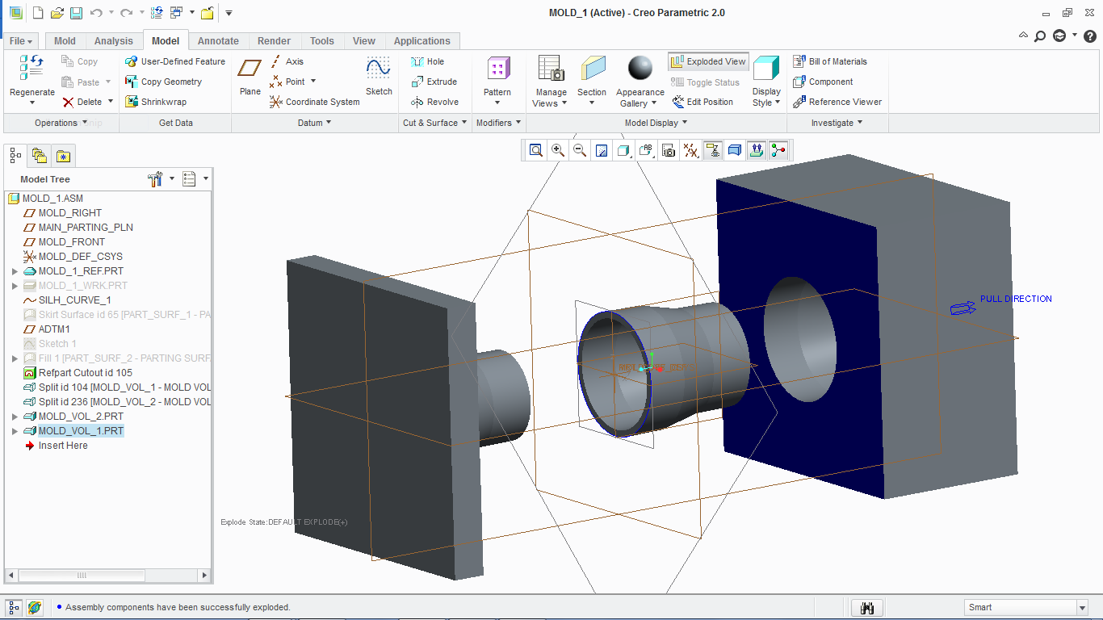

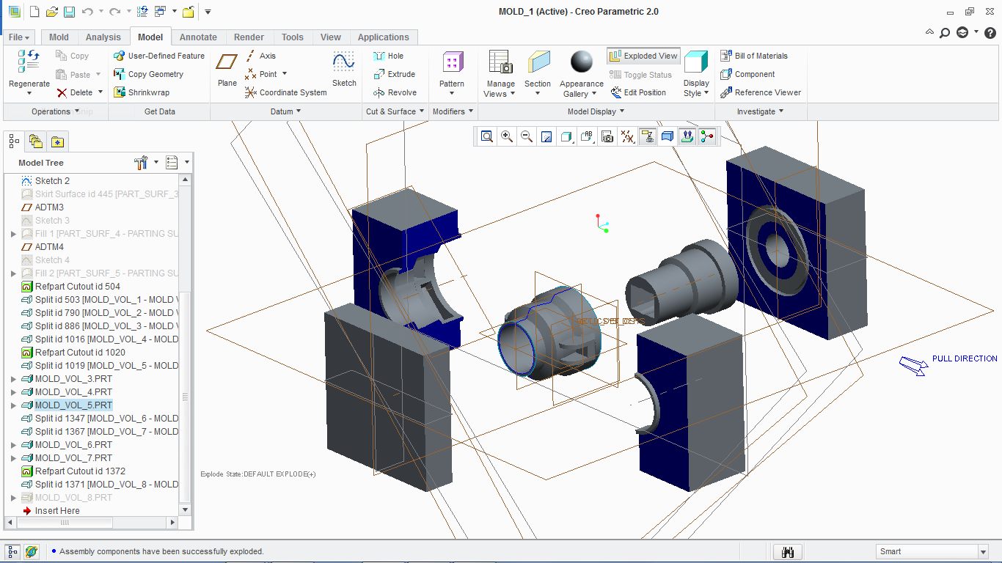

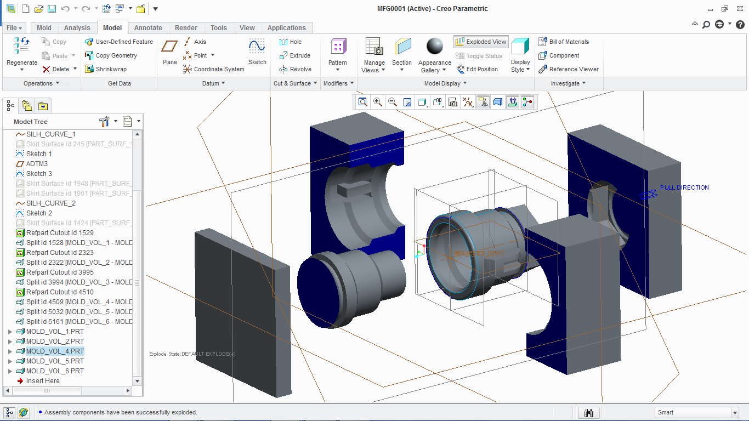

# Mold Flow Analysis:-

This project focussed on injection of plastic over the steel rod to make the handle for buckets. It involved multiple injection points, simultaneous injections, complicated runner system involving a cold sprue with cooling channels. It is important to have a mold flow analysis for the whole system as plastic flow needs to be confirmed in all the parts of the cavity and compute the cycle time of the injection cycle. The pressure drop and the average temperature also are important parameters for the analysis. The air traps also needs to be found so that apt air vents are provided to prevent defects of the molded part.

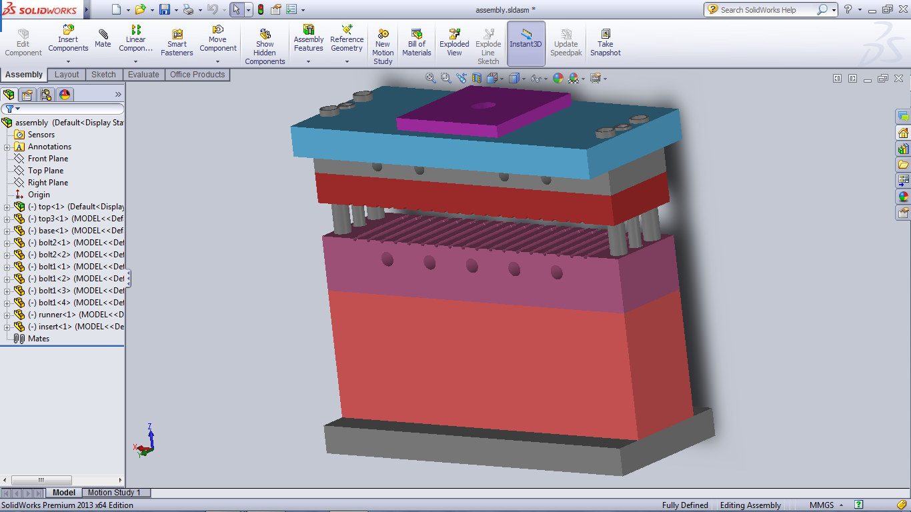

*Moldbase for Vertical Injection Molding Machine*

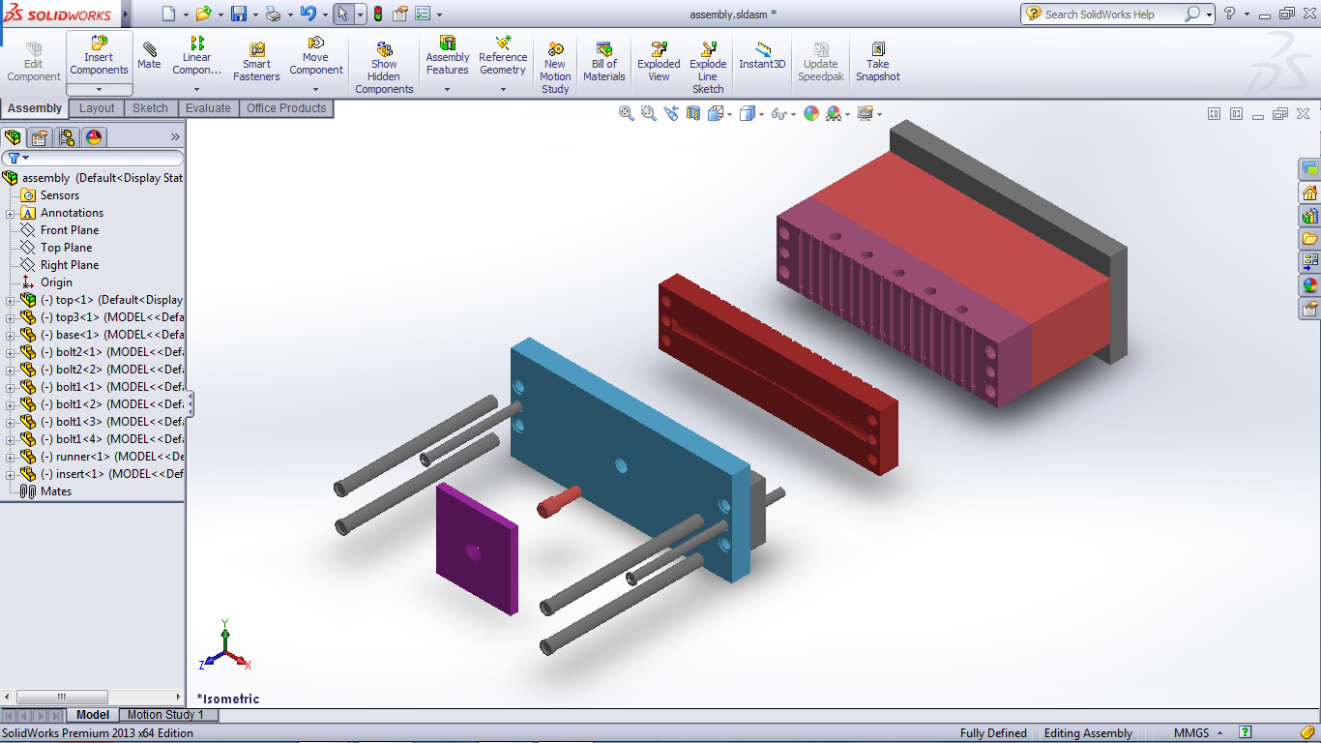

For the part two runner systems were made and analysed to find the more efficient and optimal of the two. One was for the same diameter taper runner geometry while the other was for varying diameter runner geometry. The results were then discussed upon and it was concluded that the varying diameter runner geometry would be better because of its easier machinability aspect and a satisfactory and complying flow profile.

The parameters considered were Fill time, Plastic flow, Confidence of fill, Quality prediction, Injection pressure, Pressure drop, Temperature at flow front, Average temperature, Time to reach ejection temperature, Air traps, Weld lines and Volumetric shrinkage at ejection.

The analysis was initialised with:-

* Melt temperature: 240.0 (C)
* Mold temperature: 40.0 (C)
* Injection locations: 1
* Max. machine injection pressure: 180.000 (MPa)



*Fill time for tapered runner geometry*



*Fill time for varying diameter runner geometry*

# Pricing Strategy for the Mold Designs Proposed:-

Sample calculations for a Mold Design depicting the parameters on which the pricing strategy is dependent on.

